Vice President for Research
Research Center Fact Sheet
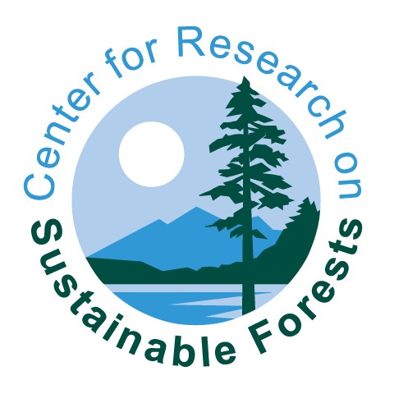

Mission:

To conduct and promote leading interdisciplinary research on issues affecting the management and sustainability of northern forest ecosystems and Maine’s forest-based economy, while engaging with various stakeholders throughout the state and region.

Funding:

$1,216,011 was received from a combination of external and internal grants and gifts to support sustainable forest-based research during FY2016. $167,580 was invested by the Maine Economic Improvement Fund (MEIF) to support center operations, leveraging $7.62 for every dollar invested.

Faculty / Student Numbers:

11 core faculty & staff, 2 collaborating UMaine faculty, 47 external collaborators, 16 graduate students, >30 undergraduate students

Major Highlights:

The CRSF is home to a new study to assess the economic impact of tourism in Maine. CRSF staff worked closely with the Maine Forest Products Council and Maine Forest Service to lead the Maine Spruce Budworm Task Force in launching a communications webpage on the SBW. In addition, two new grants from the USFS Northern Research Station for the Howland Research Forest will provide continued support for making automated greenhouse gas, eddy covariance (flux), and numerous other atmospheric measurements as part of the national Ameriflux Network. Finally, two websites geared toward meeting the needs of various stakeholders were launched. These included the NorthEast Forest Information Source (NEFIS; nefismembers.org) and the Maine Forest Spatial Tool (MFST; http://mfst.acg.maine.edu/).

Connection to Area Businesses:

The Cooperative Forestry Research Unit (CFRU) attracted over $500,000 in gifts from 36 forest products companies and conservation organizations (representing 8.3 million acres of forestland or half of the state’s total forestland) to support forestry and wildlife research.

Economic Development / Spinoff Companies:

Graduate and undergraduate student research training provides a key labor force for Maine companies, government agencies, and conservation organizations that contribute to the forest-based economy and sustainable forest management.
New Initiatives:
Integration of new technologies and enhanced data analytics to support the sustainable management of the region’s natural resources.

