PROJECT ID: CAFS.20.84
YEAR: 3 of
PROJECT TITLE: Physiologic Response to Commercial Fertilization Programs in Pacific Northwest Forest Plantations
INVESTIGATOR(S): Eric Turnblom (UW), Kim Littke (UW), Michael Premer (UM)

PROJECT DESCRIPTION:
Sustainable growth and productivity in the forest industry has been identified as a priority subject area in the National Science Foundation Industry/University Cooperative Research Centers (I/UCRC) program. This proposed project aims to assess the role of silvicultural treatments on terrestrial C sequestration and commodity production across the Pacific Northwest Region of North America and synthesize these findings into management guidelines.

Forest productivity is commonly limited by site nutrient availability, and deficiencies can result in extended rotations, forest health issues, and ultimately, unrealized volume gain. The forest products industry of Oregon and Washington contributes a combined $50 billion to the annual regional economy, and while fertilization is perhaps one of the most commonly applied silvicultural practices, little is known about the optimal timing and prioritization of lands for nutrient amendments. These processes have direct influences on terrestrial C sequestration and commodity volume and value. Therefore, additional information and site/stand conditions and quantifying causal mechanisms are needed for treatment deployment and matching silvicultural practices to site specific nutrient cycling rates and inherent productivity.

This project aims to leverage existing regional research plot networks that have been established for biogeochemical assessment of nutrient management regimes (Project ID 09.19). The utility of an existing study network offers a considerable benefit in allocation of sampling resources and time needed for completion of project and outlined deliverables. Therefore, amending this proposed sampling program to current efforts is disproportionate to the anticipated products and benefits to regional and adaptive forest management.
HYPOTHESES or OBJECTIVES:

The overall objective of the proposed project is to assess forest ecophysiology patterns in operational nutrition programs across the Pacific Northwest region. Specific objectives include:

1) Investigate causal mechanisms between edaphic variables and physiologic processes across the leaf, tree, and stand scales after fertilization and under variations in stand/site conditions
2) Provide empirical data to inform silvicultural treatment response in Growth and Yield (G&Y) prediction and projection systems and regional resource management support under current conditions and variations in future climate
3) Develop regional spatiotemporal silvicultural nutrition guidelines for commercial forest operations

METHODS:

This study will utilize fertilized and control tree-based plots in the SMC Type V Paired-tree project across Oregon and Washington, USA and British Columbia, CAN. These sites cover the major physiographic sub-regions characteristic of the PNW across a range of plantation ages and site and stand conditions. The SMV Type V uses a paired-tree approach, with extensive soil chemistry, micrometeorological, and foliar nutrient data collected prior to and after treatment (Littke et al. 2014).

A subset of thirty installations from the SMC Type V study was sampled from responsive (0-4+ year basal area response), temporary responders (0-2 year basal area response), and non-responding (no significant response) for a total of 10 per response type. Up to 20 trees per treatment will be selected from each installation for collection of increment cores (Figure 1). Cores will be taken at breast height (1.3 m) and processed for cross-dating at the UW. Stem rings will be measured for total ring growth to the pith and earlywood and latewood from 2005. For each installation, up to ten paired tree cores per treatment that were accurately dated will be split into earlywood and latewood four years prior to fertilization and six years post-fertilization and will be composited by year, component, treatment, and installation. Measurement of δ¹³C and δ¹⁸O at Columbia University will determine the relative impact of N addition to A/gs patterns and explore these variables across ranges in site and stand conditions. These methods have been effectively utilized to assess physiologic response and intrinsic water use efficiency in conifer thinning studies (Warren et al. 2001; Powers et al. 2010) and fertilization treatments of Douglas-fir (Brooks and Coulombe 2009; Brooks and Mitchell 2011; Cornejo-Oviedo et al. 2017) in single site experimental units. Tree-ring derived growth rates and isotopic composition (i.e. Δδ13C) will be used in conjunction with micrometeorological data to assess the relative contribution of edaphic and stand conditions on physiological utilization of N. We anticipate using a variety of statistical methods for analysis and predicting response by site and stand conditions with linear and non-linear mixed models using the glmm (Knudson 2018) and nlme (Pinheiro and Bates 2018) packages in R statistical programming environment.
MAJOR FINDINGS:

- Responding installations grew larger ring areas up to ten years after fertilization. The greatest ring area growth was found in the first four years after fertilization (Figure 2). Earlywood growth response peaked in the first two years after fertilization while latewood growth response decreased after four years. Installations that responded temporarily to fertilization (0-2 years) only grew greater earlywood or latewood for the first year after fertilization and then grew similarly to control trees. Some non-responding installations also had a slight increase in ring area growth in the first year but tended to grow less than the controls over time. In some cases, fertilized trees in non-responding installations grew significantly lower ring area than control trees.
- Fertilization increased earlywood water use efficiency (WUE) in responsive installations over non-responsive installations for four years after fertilization (Figure 3A). Installations that responded temporarily to fertilization were not significantly different from responding and non-responding installations two years after fertilization. Latewood WUE response was only significantly greater in responsive compared to non-responsive installations in the first year after fertilization (Figure 3B).
- There were no significant differences between response in δO18 in earlywood and latewood after fertilization between responsive, temporary responsive, and non-responsive installations (Figure 3C and 3D).
- Earlywood and latewood WUE and δO18 were positively linearly correlated with Spring and Summer temperature and negatively linearly correlated with Spring and Summer precipitation (Figure 4). Earlywood and latewood ring area were negatively correlated with temperature and WUE and positively correlated with precipitation in the Spring and Summer. The interrelationships between climate, WUE, and ring area suggest that hotter, drier Springs and Summers result in lower stomatal conductance that increases WUE and decreases ring area growth.

DELIVERABLES:

Thirty SMC Type V installations have been measured for ring area growth and response to fertilization. From each installation and treatment, earlywood and latewood samples from four year prior to and six years post fertilization will be analyzed for δ¹³C and δ¹⁸O to understand the effects of fertilization and edaphic variables on physiologic response. Plant Root Simulator probe data from control and fertilized trees will be collected to determine the nutrient limitations at each installation and any long-term effects of N fertilization. At the end of this project, the deliverables will be three publications submitted to peer-reviewed journals that reflect each project objective and a study design that can be applied to national forests through the Center for Advanced Forestry Systems.

MEMBER COMPANY BENEFITS:

Synthesize the quantification and assessment of observed correlations between stand structure, edaphic variables, and N fertilization physiologic response into regional silvicultural recommendations for Douglas-fir plantations. Improve silvicultural recommendations for Douglas-fir plantations based on physiologic response.

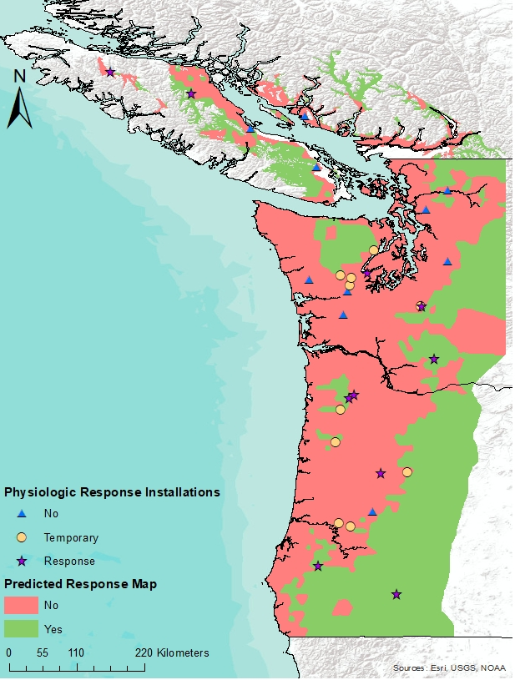
Figure 1. Stand Management Cooperative Type V Paired-tree installations that will be sampled in this study.

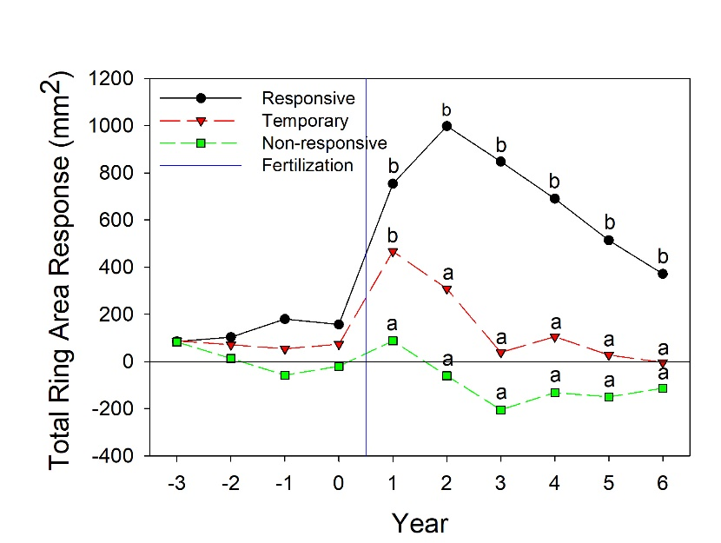
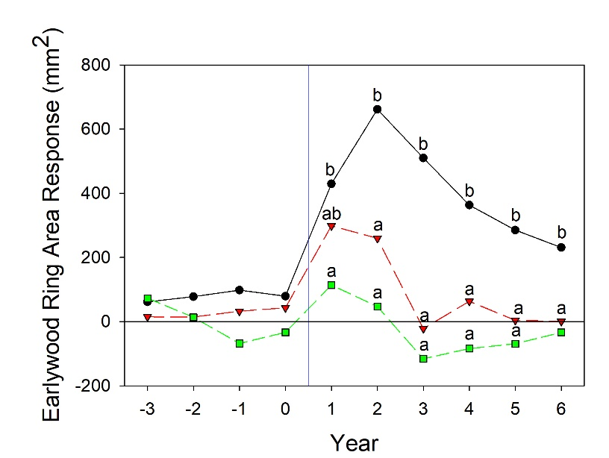
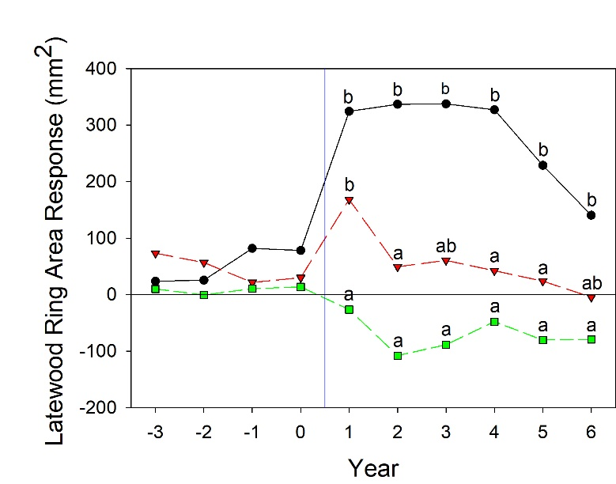

A.

B.

C.

Figure 2. Mean response in total ring area (A), earlywood (B), and latewood (C) growth per year due to fertilization on installations that responded (n=10), temporarily responded (n=10), and were non-responsive (n=10) to fertilization over six years. Points with different lowercase letters were significantly different between response types for each year since fertilization (p<0.10).

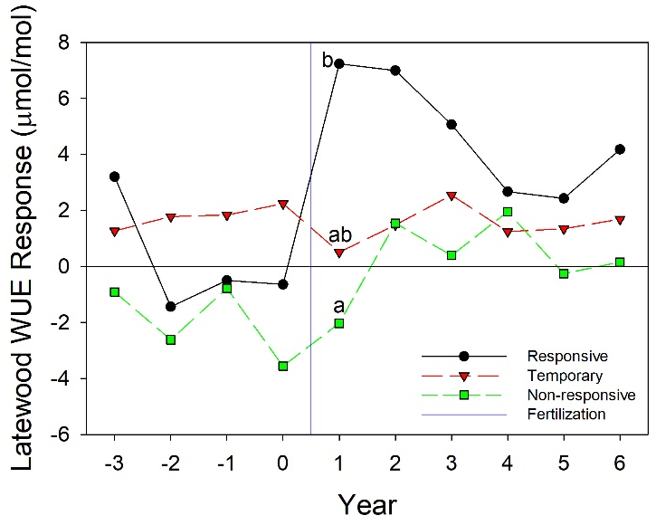
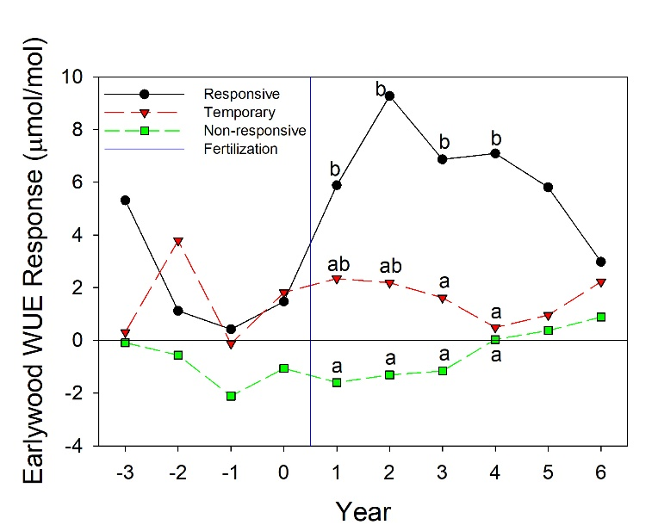
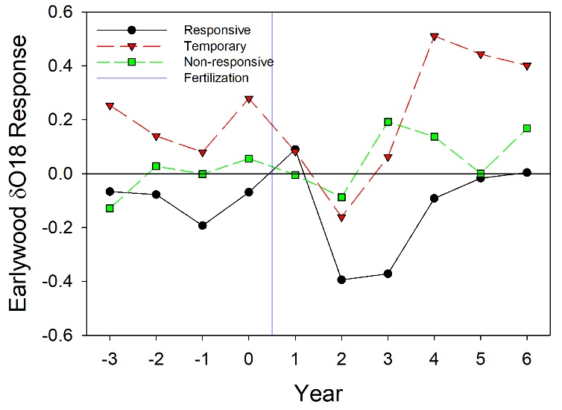
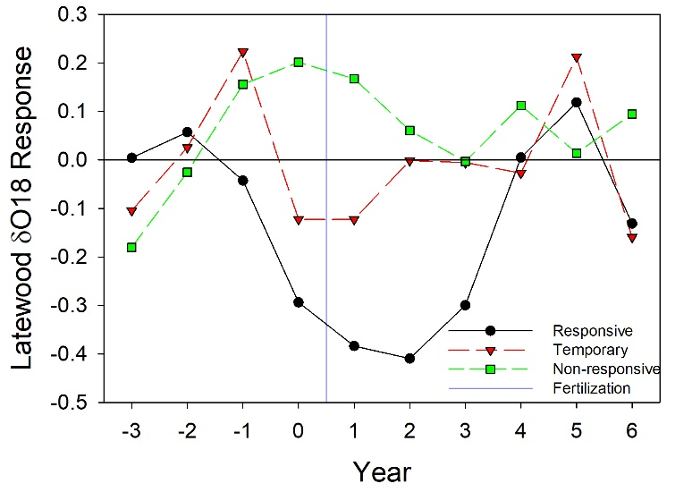

A

- B.

C. D.
Figure 3. Mean response in earlywood (A) and latewood intrinsic water use efficiency (WUE) and earlywood (C) and latewood (D) δO18 due to fertilization on installations that responded (n=4), temporarily responded (n=6), and were non-responsive (n=7) to fertilization over six years. Points with different lowercase letters were significantly different between response types for each year since fertilization (p<0.10).

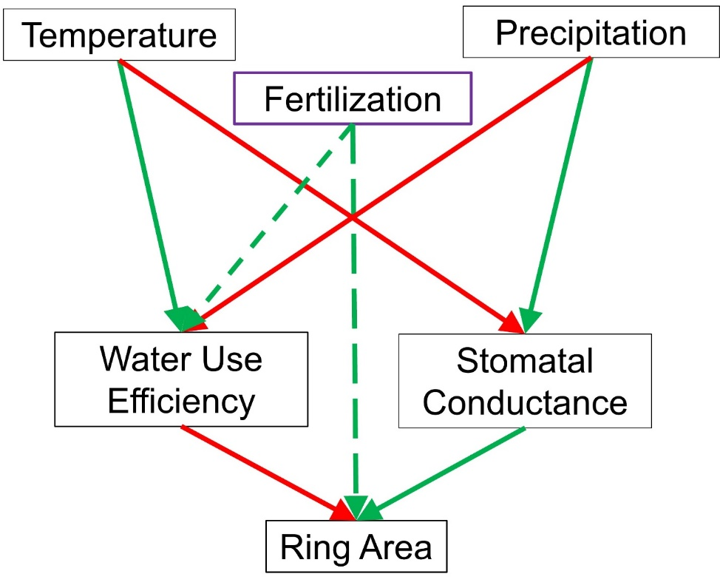
Figure 4. Linear positive (green) and negative (red) relationships between seasonal climate, water use efficiency, stomatal conductance, and ring area. The effect of fertilization is shown for responsive installations.

