PROJECT ID: CAFS.16.69
YEAR: 8 of
PROJECT TITLE: Stand and Tree Responses to Late-Rotation Fertilization
INVESTIGATOR(S): Eric Turnblom, Kim Littke, Jason Cross, Mason Patterson, and Rob Harrison (UW)

PROJECT DESCRIPTION:
The study is designed to estimate a regional nitrogen fertilization response (RRE) for Douglas-fir on late-rotation stands. This estimate will be derived from paired-plots in randomly located late-rotation stands within four distinct regions of Washington and Oregon and two regions in British Columbia. We will compare the use of anion and cation plant root simulator (PRS) probes and traditional available and total soil nutrient extractions to understand what is affecting fertilizer response in late-rotation Douglas-fir plantations.
HYPOTHESES or OBJECTIVES:

- Determine the average, area-based volume response to late-rotation fertilization in stands being considered by landowners for fertilization
- Estimate the regional economic returns to late-rotation fertilization investments
- Validate the site-specific responsiveness prediction of the current model developed from the Stand Management Cooperative and CAFS Paired-tree Fertilization study
- Assess the ability to predict late-rotation response to fertilization across the Pacific Northwest according to PRS probes and available and total soil nutrition.
METHODS:

Stand Selection. The population of interest is late-rotation managed Douglas-fir stands in Oregon, Washington, and British Columbia that landowners are considering as candidates for fertilization. Late-rotation will be defined as 8-10 years before final harvest with the actual harvest age defined by the landowner and bracketed by stands between 28 and 50 years total age. Candidate stands will have at least 75% of the basal area in Douglas-fir with at least 85% of the basal area being conifer. Stands could have been thinned (PCT or CT) or fertilized in the past.

Thirty-two sample stands were allocated across four zones (in the U.S.) in proportion to industrial forestland area within each zone or stratum. Figure 1A depicts the four strata that were used for sampling stands in the U.S based on a melding of soil parent material characteristics and physiographic attributes. The two defined strata in B.C. are industrial forestland on the east side of Vancouver Island and west side of the mainland (Figure 1A). Three installations were established in each of the strata in B.C. Stands were selected by first randomly choosing latitude/longitude coordinates within the boundaries of the forested area within each stratum. Then, members owning land within a radius of 3.38 miles (5.44 km) provided a list of candidate stands within the defined circle.

Installation Description. An installation contains a pair of plots that were established in uniform conditions. Plots were between 0.2 and 0.5 acres (0.1-0.2 ha) based on stand density such that each plot contained around 75 trees. All plots have a 32.8-ft (10 m) treated (or untreated) buffer.

Four or five temporary plots were created and diameters tallied by species. From these data, the two most similar plots according to diameter distribution and basal area were selected for the study. The final paired plots were within ±10% for basal area and ±10% for quadratic mean DBH (QMD). Also, the non-conifer proportions of each plot in a pair had similar species composition. Once a pair was found, the two study plots were established with all live trees > 2.0” DBH tagged (or painted) with a unique tree number and measured for species, diameter at breast height (DBH) located at 4.5 ft (1.37 m), total height (HT), and height-to-live-crown (HLC), and general comments.

One plot in each pair was randomly assigned the fertilizer treatment. The fertilizer treatment plot (measurement plot with buffer) was treated with the equivalent of 200 lbs/acre of N using best practices (time of year, weather conditions and uniformity). Fertilization was carried out in March-April in WA and OR installations and in November in B.C. installations.

The plots will be remeasured two, four, six, and eight growing seasons after fertilization treatment for tree status (live/dead), DBH, HT, and HLC. Responsiveness of each installation will be determined by the difference between the control-calibrated predicted growth on the fertilized plot and actual fertilized plot growth (McWilliams and Burk 1994). The actual proportion of the response will be tested against the expected responsiveness of 1 (no difference to control). The tree lists can also be projected on SMC-ORGANON to anticipated harvest age (5 – 10 years) and an economic analysis done using merchantable volume and average log values, costs, and interest rates for cooperators.

Pre-treatment soil nutrients were sampled on both paired plots. One soil pit to a depth of one meter was sampled by depth for soil nutrient analysis (carbon (C), N, exchangeable cations, and Bray phosphorus (P)). Three forest floor samples of known area were composited per plot. Anion and cation plant root simulator (PRS) probes were installed horizontally in each plot at 2-in soil depth in the spring during fertilization. The probes were installed in four randomly located pits within each plot and then removed 12 weeks later. During the first growth measurement (two growing seasons after establishment), foliage, branch, and tree core samples will be removed and analyzed for total C and N and total metals. We will determine if forest floor, soil, and tree nutrition are indicative of late-rotation Douglas-fir fertilizer response.

MAJOR FINDINGS:

- Four-year percent tree volume response and volume response per acre were positively correlated (Figure 1). Disparities in volume response per tree and per acre were due to differences in mortality between treatment plots. There was no significant effect of fertilization on four-year mortality. However, there was a slight increase in mortality of suppressed trees in fertilized plots of dense, low-productivity installations. Because there was no significant effect on mortality between treatments, trees that died during the current measurements were not included in the calculation of stand volume response (Figure 1).
- Four-year volume response per tree and per acre was significantly greater in regions predicted to respond in the Paired-Tree Study fertilization model (Figure 2A). The average four-year volume response in predicted response regions was 27 ± 28% per tree and 59 ± 45 ft³/ac/yr, while non-responsive regions were 11 ± 22% per tree and 17 ± 47 ft³/ac/yr. When comparing data from the Paired-Tree and Late-Rotation studies, predicted response regions also significantly lower site index, PRS NO3 supply rate, and foliar N and greater surface soil C:N ratios. Therefore, the regions with predicted response from the Paired-Tree Study were more responsive due to lower N availability and site productivity.
- There were no significant differences in volume response per tree or per acre from 0-4 years according to physiographic region (Figure 2B). B.C. West (Vancouver Island) and Oregon West regions contained the greatest tree volume response and stand volume growth response at four years. The lowest response per tree and per acre was found in the B.C. East (Mainland) region.
- The best predictor of volume response per tree in the Late-Rotation study was low PRS NO₃ supply rate (<50 mg/10cm²/12 weeks) (Figure 3). 72% of installations with low PRS NO₃ supply rate responded well in fertilizer volume response per tree. Installations that contained low NO₃ adsorption and received no measurable fertilizer response (5/18) either were limited in other nutrients or had adequate adsorption of NH₄.
DELIVERABLES:

Thirty-eight installations have been installed, measured, and treated. Pretreatment soils have been analyzed on all installations. The relationship between PRS probe uptake and soil and site productivity and four-year fertilizer response on the Late-Rotation stands will be presented at the North American Forest Soil Conference and published in a peer-reviewed journal. We will compare site-specific response in the younger tree-based Paired-Tree and older plot-based Late-Rotation studies. At the end of this study, we will do an economic analysis of regional fertilization of late-rotation stands for inclusion in growth models. We will prepare final reports on regional fertilizer response and effects of aboveground and belowground nutrition on late-rotation response.
MEMBER COMPANY BENEFITS:

This study will provide a much-needed examination of the economics involved with late-rotation fertilization. We will provide an average area-based volume response that will be used in growth models in six distinct regions. This study will allow us to test the use of aboveground and belowground nutrient allocation and PRS probe uptake in predicting fertilizer response.

Figure 1. Relationship between fertilizer volume response per tree and volume response per acre in all trees and only living trees at four years.

A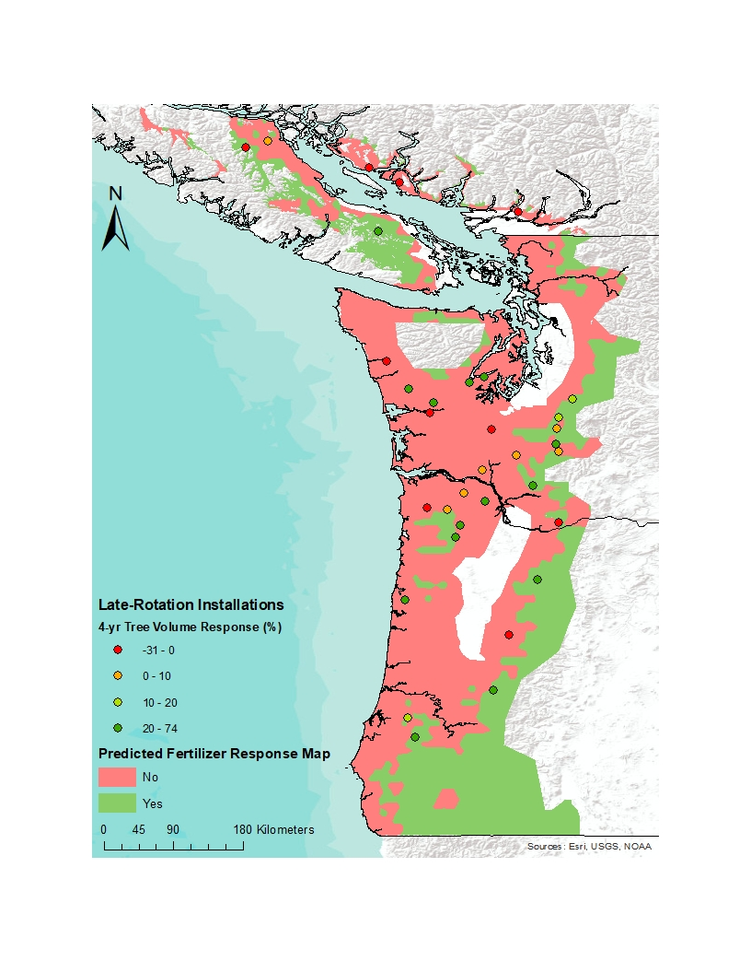 B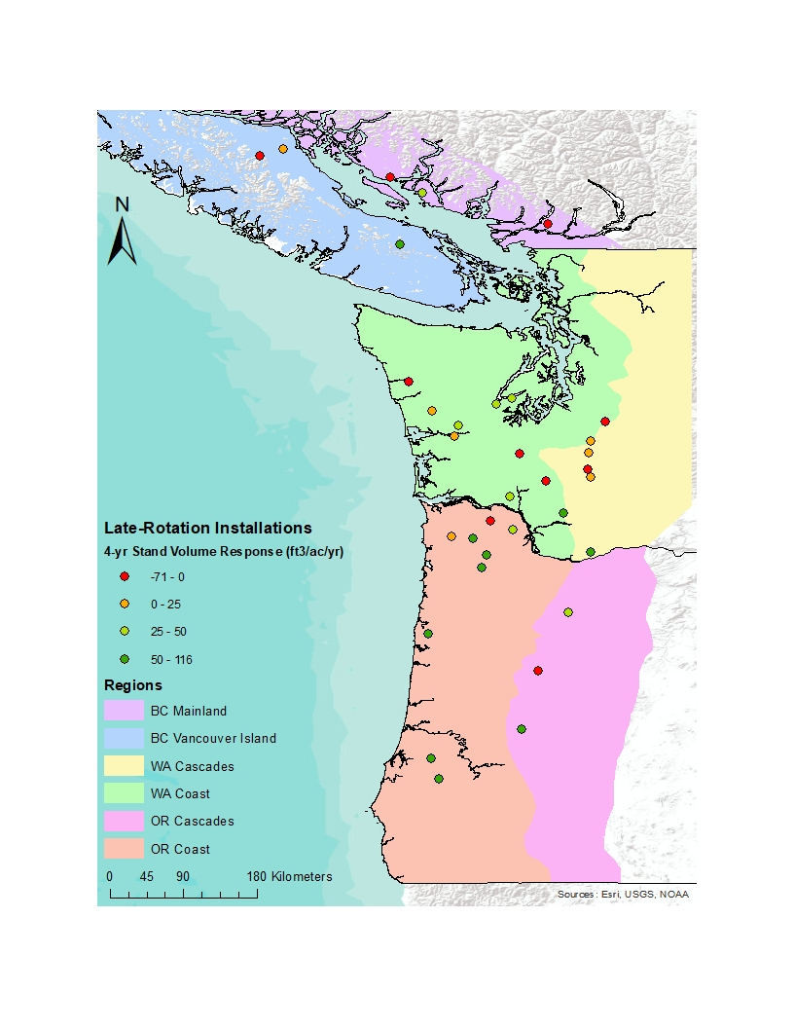
Figure 2. A. Predicted response regions from four-year per tree volume response in the Paired-Tree Study compared to measured four-year tree volume response from the Late-Rotation Study. B. Four-year plot response (ft³/ac/year) in each physiographic region of the coastal Pacific Northwest.

Figure 3. Relationship between Plant Root Simulator probe NO₃ adsorption and fertilizer volume response per tree from 0-4 years.

